HOST Side Winder Guide
August 22, 2014

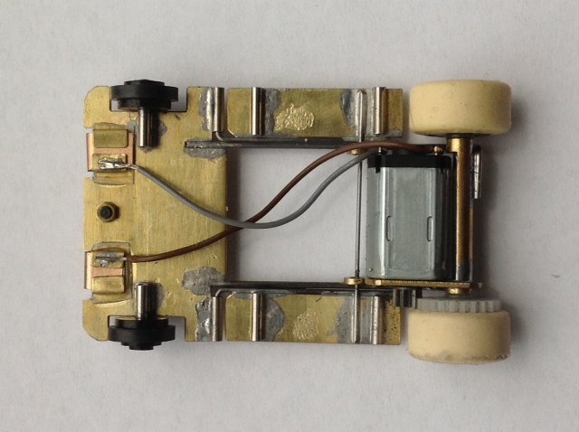

HOST Side Winder Guide
Table of contents
- Preference
- Motors – Specs, care, maintenance, and replacement
- Tires/Wheels/Track – Removal, installation, and replacement
- Wiper/Pick-ups – Adjustment, removal and replacement
- Weight – Optimal range and placement
- Bodies – Types and mounting suggestions
- Controllers – Ranges and recommendations
- Gears – Background, maintenance, and replacements
- Parts source list
Preference
In the early 1970s Pat Dennis was working at Tyco and developed several prototype anglewinders and a sidewinder that he proposed to be the next cars out from Tyco. While Tyco chose not to go in that direction, Car Model did a feature story on these prototype cars that captured the imagination of many of their readers. These were HO scale cars that emulated the 1/24 technology of that period and boy was I hooked. I had already built an angle winder, based on a Car Model article, but it was nothing like Pat’s work.
Flash forward forty years and Ron Bernstein has convinced Pat to recreate his sidewinder from the 1970s and sell a short run of them. I recognized his ground breaking work in the 70’s had a place with our developing gravity class racing - which lead to some inevitable conversations and collaboration between Pat and I that ultimately resulted in significant design considerations in your sidewinder. I have also integrated some modern 1/24 scale group car designs and three season of gravity car racing to incorporate into this finished car. The results; a car that has won races in the Midwest Series gravity racing class, drives and looks like a little 1/24 scale car. I hope you enjoy driving one as much as I do!
Motors – Specs, care, maintenance, and replacement
Your car comes with an M-20 production motor. These motors are built in Asia with intended applications for vibrators in cell phones, CD motors, digital camera focusing mechanisms, etc. The M specifies the size of the motor, with it being .310 tall on the flats of the can; the 20 specifies the length of the motor. The weight of the motor is somewhere short of 4 grams.
The supplied sidewinder motor has 6 ohms of resistance, which seems to be sweet spot for Gravity cars. The wipers or pickups on Gravity cars have limited power delivery with their low contact pressures, which translates into a big amp motor being power starved, thus arching the pickups and therefore, not faster. I have found that anything lower than a 3.5 to 4 ohm motor puts you in this range in gravity racing. A motor above 9 to 10 ohm, while kind on the pickups/wipers, typically seems to leave you short on speed.
The brush system on these motors is a precious metal system with three wiper fingers that contact a .080 diameter cylindrical commutator. They are typically designed to support two to six volts of power. As we are running these motors way outside of their intended voltage range, this has an impact on their running time. From our experience they have user times no less than a full race weekend on 18 volts, but some have performed well for an entire season. I would not think of them as a multi-season motor, but at $5.00 or less a unit, that is a reasonable user expense.
Magnets in this particular motor are radial oriented polymer magnets that are .040 thick. I have seen other M series motors that have ceramic and neodydum magnets. All can be fast, but can drive differently. As expected the Neo magnets can have the most brakes and acceleration, but sometimes this loses out to a lack of flow. None of these motor should run hot, at best only luke warm. If they do run hot something else is wrong.
Motor “dos and don’ts”:
- DO NOT free rev these motors. They are not epoxied or wrapped and will potentially throw a wire. That stated, it is safe to free rev them at 4 volts or less, as these are not problematic speeds.
- DO run these motors in the intended direction, the correct direction pulls the wiper/brush. Your sidewinder is set up in the correct direction. The brush’s wiper system might be damaged by running it backwards (push direction).
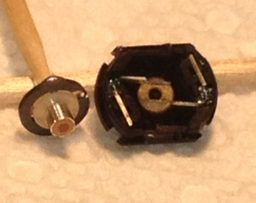
- DO routinely oil the front and rear oilite bushings (picture). I would recommend every 20 minutes or so. I find that the BSRT oiler can nicely access the front oil hole. Use oil intended for bushings. Keep the amount minimal – we don’t want an oil soup can on the inside!
- DO eliminate front/rear wheel hop. This creates a pulsing current to the motor that may shorten run time of the motor. See the wiper, tires, and weighting sections for recommendations here.
Motor sources – I can supply you with a replacement unit for $5.00 with the return of the used unit. E-bay and the internet can support you finding numerous other mini motors. The can spacing for the screws seems to be standardized and utilizes a 1.4mm screw, so attachment to the bracket should not be an issue.
Tires/Wheels/Track – considerations, removal, installation, and replacement
Tires are the most critical element in the performance of a gravity car. You can have all the motor in the world and if you cannot get it transferred to the track you will never reach your car’s potential. Tires and motors therefore need match; something I have worked hard to achieve over the last three seasons. Tire wear is quickest on gravity cars of all the racing classes, probably due to their wheel spin with low down force.
A dirty track will dramatically affect your car’s performance. Our recommended cleaning for gravity racing on your track is to:
- Dry wipe the track one to two days before your planned usage or race.
- Follow this dry wipe with a light application of WD-40 to a rag and wipe track.
- Dry wipe the track just before your planned session.
- Periodic dry ragging of the track might be needed during your session/races dependent on the environment.
- The microfiber cleaning cloths work very well. Clean cotton also works well.
The rear wheels of the sidewinder are a non- standard dimension, and there is a right and left wheel to accommodate the gear boss; therefore Host will need to be your supplier for tire/wheels for the sidewinder.
Wheel removal and installation can usually be done with standard puller and press-on tools. Order of operation needs some consideration. For removal of the wheels you will need to:
- Remove the passenger wheel (flat backed wheel) first with your puller tool
- Slide the axial wheel assembly out the driver side
- Remove the driver wheel (pocketed back wheel) by placing the puller tool behind the spur gear and moving them as a pair
- Once the driver wheel is free you need not slide it any further to remove the spur gear
- Note that when changing a motor, you will need remove the wheel assembly to access the bracket screws.
Installation of wheels:
- Position your spur gear with your press on tool or fingers if you are talented. Check with calipers to get correct.
- Place the axle gear assembly in the axle tube and press on the passenger tire.
- Adjust for lateral play.
- Press on the driver tire and recheck lateral play.
Wipers (pick-ups) – Adjustment, removal and replacement
These are one of the life bloods of a Gravity car. Like a T-jet, their adjust zone is very narrow and creates a critical balance between handling and speed. A wiper has some unique advantages over a pick-up: it is lighter, has a narrower travel range, and can have it’s contact patch adjusted. That said you will need to learn to make them and adjust them, which can feel daunting at first. The tools are simple to make wipers: sharp small scissors, calipers, and some 400 grit sandpaper. Let’s first discuss how to make wipers and then follow it up with how to adjust them.

Making wipers
- You will need a sheet of .003 phosphor bronze. I suggest Quicker Engineering as a source (see parts suggestion area).
- Lightly score a .180 line on one edge of the sheet
- Cut with your scissors on your scored line to make a strip .180 wide. I would suggest that the strip be between 1.5 and 2.0 inches long, as this make a manageable length to work with and will make two to three wipers.
- On your just cut strip lightly score a line for length at .650 inches and cut with your scissors.
- There will be some warping of the wiper strip and now is the time to correct this and make the strip flat. On a flat piece of wood place the wiper strip curved side down (concaved) and with your thumb nail do a series of longitudinal strokes on the wiper to flatten it.
- Once the wiper strip is flat you will you need to address the burr at the edges of the bronze left by the scissors. If your scissors are sharp this burr should be minimal. Local burr/curling at the edges, and especially at the corners of the strip, can be initially address by the same method outlined in step 5, but more aggressively. I often use local pressure with the blunt end of an X-acto handle to press the burr/curl on a piece of wood or harder surface. Final flash can be removed by lightly sanding with 400 grit paper or a 220 grit Scottbrite radial brisal disc (the same one use to clean pickups).
- Now you should have a flat, burr free wiper strip and we will now proceed with bending it. With your calipers, lightly score a line at .200 inches. On this line place the round end of a .059 drill ( I included one in your initial package) and make a 180 degree bend of the wiper strip. Test fit the wiper in the wiper holder and make the needed adjustments to the angle and clearances of the wiper. Some scissor trimming might be needed for the wiper to fit properly in the holder.
- The trailing end of the wiper will need to have its corners rounded, so they do not snag the rails as the cars swings and transitions in the corners. Again cut these corners carefully with sharp scissors. If a burr develops here this will need to be addressed so as not to have a catch point.
- The track side of the wiper is approximately .425 to .440 inches long. Some experimentation might be needed here for your cars weight and track it is set up on.
- A slight curvature to the installed wiper is desirable, to avoid contacting only the trailing edge. I achieve this by placing an X-acto blade under the installed wiper and drawing it back with light pressure from my finger above. It can also be done on the uninstalled wiper on a piece of wood with a small drill blank held in a pin vise. Place the drill blank on the underside of the wiper and side it back and forth with sufficient pressure to create a slight curvature.

Adjustment of wipers
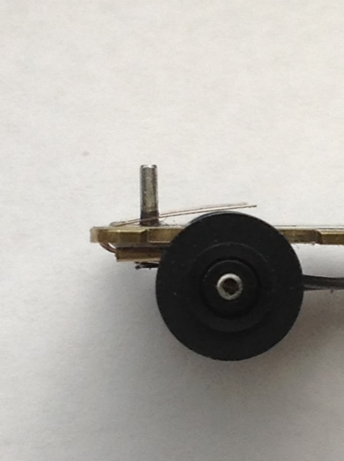
- First check the side profile of the wiper on the track. The front leading edge of wiper should have clearance; if it does not, the leading radius you bent over the drill end needs to be reduced. Do this by removing the wiper and lightly pinching the bend and then rechecking for clearance.
- Continuing with the side profile check on the track, next check that the rail contact starts at about midway on the wiper. As noted in step 10 of making wipers, there should be a slight curve to them that makes this midpoint contact happen, ensuring that they do not run exclusively on the end.
- Now check the side profile of the wiper off the track. The wiper should be positioned slightly beyond the wheel exactly as pictured. Adjust this by either lightly lifting the end of the wiper to raise it or pinching the front to lower it. When this adjustment is correct your front wheels will lightly be touching the track or slightly raised from the track.
- Now look at the wipers from the rear of the car. They should appear level. If not they will need to be tweaked to make them so. I do this adjustment with fine tweezers, or an X-acto blade placed underneath the front of the wiper.
Weight – Optimal range and placement
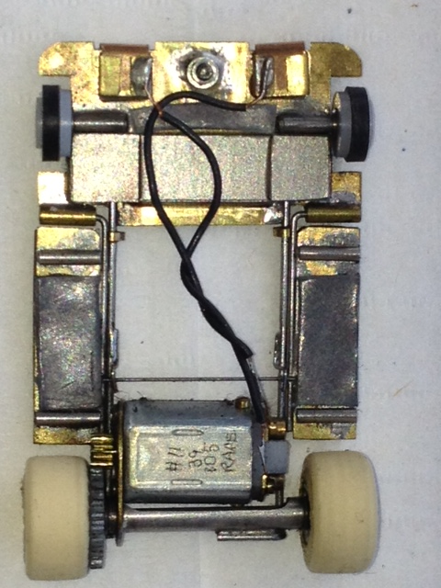
Without any weight added to the base sidewinder it is less than fourteen grams. At this weight I have found too much wheel spin and tendency to hop out. From my testing, optimal weight is around eighteen grams - dirty/bumpier tracks might need more than this; smooth fast tracks might allow you to get by with less. Pictured is a generic weight distribution you might use as a starting point. I use .032 stick-on lead weight from Lucky Bob’s, which makes for quick adjustments on race day. I mark dimension lines on the lead with calipers and cut to the lines with scissors.
Bodies – Types and mounting suggestions
Chassis with the M motor are very flexible for mounting bodies. They do not require the large “dome” type of body that the traditional HO car needs to accommodate it’s relatively huge motor. Bob Dame has developed two bodies that are still in the prototype stage that are specific to the mini-motor cars. These bodies take advantage of the ability to mount much lower, providing a more 1/24 look. Bob can probably be talked into selling you some. Other bodies I like for the sidewinder are the Howmet by Host and the Peugeot by BSRT.
A little body float is desirable in a gravity car. The side pods set up for some nice vibration damping, but additional floating of the body helps further. Damping vibration keeps your tires on the track! The body tubes have a generous .043 inch hole, which if centered correctly with a .032 or less body pin, assures you of a float.
Controllers – Ranges and recommendations
A gravity car, more than any other HO car class, has the greatest corning to straightaway speed difference. This makes controller selection and settings very critical. I spent several seasons frustrating myself with this. A typical electronic controller will be too fast for a gravity car on the low end for your critical cornering speeds; even ones specific to T-jets may be too fast. In the electronic controller world, I would strongly recommend the one made by Lucky Bob that has three adjustment dials. This controller has been a breakthrough for us this last season in both single lap times and totals. In the rheostat world you will need something in the range of 90 ohms to 120 ohms dependent on the track and your driving style. You will frustrate yourself, especially with the supplied production motor, thinking the car is too fast when it really is a controller issue.
Gears – background, maintenance, and replacements
A 64 pitch 23th spur gear that is made by HOST is supplied with the car. A cut down 7th M-Car gear is utilized for the pinion gear; please recycle these as I am not sure of the future of this company. Over the last three seasons I have found the 7/23 ratio to be the most desirable. An 8/23 and a 7/24 can also be fitted into this bracket.
The pinion gear is designed to be a press fit on the 1mm shaft of the motor. It should be pressed on to where there is a minimal gap of say .010 between it and the bushing when the motor is in the self-centered position. Over time or if you are concerned with slippage of the pinion, application of Loctite could be done. I would recommend red grade Loctite, stronger grades are simply over kill in gravity racing.
The spur gear is made of Delrin and designed to be a press fit on a 1.5mm drill blank. It has a .060 wide shoulder that is designed to increase the press fit and keep the gear square with the axle. This shoulder is positioned properly by having it’s orientation to the outside of the car.
A small amount of grease may be applied to the gears. I recommend the red synthetic grease as this will not attack brass parts, whereas the sulfur in an MD grease will. Be careful when greasing not to over apply, as the spur gear is right next to the driver side rear tire, and over flow could destroy that tire’s traction. These are definitely multi-season gears.
Removal of the spur gear occurs by:
- Remove the passenger side rear tire with a wheel puller.
- Slide the axle out
- Remove the driver side rear wheel and gear as a pair with the wheel puller.
- This now sets you up for a wheel change or motor maintenance.
Parts source list – Specific for sidewinder and gravity cars
- Gears, tires/wheels, motors, bushings, screws, guide pins - Available through Host: email to rnethost@gmail.com
- Wiper material – Available through Quicker Engineering: quicker_us@yahoo.com
- Controllers, lead weight - Available through Lucky Bob’s 414-327-4003
- Bodies specific for M motor chassis – Host: www.horacingbodies.com/
- Host anglewinder – Available through Scott Terry at maskterry@frontier.com

